Equitable ear and hearing health outcomes for

Māori and Pacific Tamariki
  - Report on 2021 Survey and Virtual Hui
Contents: Rārangi Ūpoko
Abbreviations: Ngā whakarāpopoto 4
Glossary: Kuputaka 5
Foreword: Kupu o mua 6
Acknowledgements: He mihi 6
Introduction: Kupu Arataki 7
The state of ear and hearing health for Tamariki in Aotearoa 8
Specific Aims of the Project 9
Kaupapa Māori and Pacific Methodologies 10
Research Design and Methods 10
Online survey and virtual hui 10
Online Survey Results 13
Close ended-questions – Demographics 13
Close-ended questions 16
Open-ended questions 18
Theme One: Tamariki missing out on EHHC and childhood development 18
Theme Two: Barriers to support and EHHC services 18
Theme Three: Facilitators and possible solutions for equitable EHHC 19
Hui results 19
Participants 19
Systems thinking: What’s holding the issues in place? 20
Theme One: EHHC and Institutional Racism 20
Theme Two: Policies maintaining status quo 21
Theme Three: Power dynamics in EHHC 21
Theme four: Workforce issues 22
Theme five: Perspectives of hearing loss 23
Re-imagining a Future Reality 24
Future Research Directions 24
Collective Action Building 25
Conclusions: Ngā kōrero whakamutunga 26
References 27
Appendices 28
Appendix 1: Table - Themes from online survey 28
Appendix 2: Table – Virtual Hui themes 33
Appendix 3: Table – Re-imagining a Future Reality 35
Resources and Websites recommended in Virtual Hui 37

Abbreviations: Ngā whakarāpopoto

AoDC | Advisor on Deaf Children
B4SC | B4 School check
DHB | District Health Board
DNA | Did not attend
EHHC | Ear and Hearing Healthcare
ENT | Ear, Nose, Throat Surgeon/Specialist
GP | General Practitioner
NZ | Aotearoa New Zealand
NZSL | NZ sign language
OME | Otitis media with effusion
SLT | Speech and language therapy
UNHSEIP | Universal Newborn Hearing Screening and Early Intervention Programme
WNB | Was not brought

Glossary: Kuputaka

Aotearoa | New Zealand
Hauora | Health and wellbeing
Kaimahi | Worker
Karakia | Prayer
Kaupapa | Attending to the main purpose of the encounter or collective vision
Kōrero | Speak
Māori | Indigenous peoples of Aotearoa New Zealand
Mihi whakatau | Introduction
Pākehā | New Zealander of European descent
Tamariki | Children
Te Reo Māori | Māori language
Teina | Younger sibling
Tuakana | Older sibling
Tuakana-Teina | Refers to the relationship between tuakana and teina. The meaning is literally “older sibling-younger sibling”. Traditionally, it is specific to teaching and learning in the context of Māori. It has been used to talk about teaching and learning relationships in NZ.
Whakapapa | Genealogical layers that form the basis of Māori ways of knowing, being, and doing
Whakamā | Ashamed, shy, embarrassed
Whakawātea | Reflecting and clearing the pathway
Whakawhanaungatanga | The action of building and/or maintaining relationships and connections
Whanaungatanga | Relationship, connection
Whānau | Immediate and extended family network

Foreword: Kupu o mua
This work arose from the observations of many people involved in the lives of those Deaf and Hard-of-hearing. The project team notice that whilst identification of hearing and ear problems has occurred, there were some children who “missed out” on opportunities for intervention. This is sometimes more apparent in older children and adults who have “missed out” over a long period of time, with often significant implications.
Nearly half of tamariki with hearing loss live in significant deprivation (index 8 to 10), a majority of whom are Māori and Pasifika. This clearly reflects the experience of those working and living with tamariki with hearing loss - there are significant additional challenges to manage when you are living in poverty. These same observations are true for middle ear problems.
We reflected on how hearing professionals, as part of a system supporting those with hearing loss, were able to respond to these observations. The result was a recognition that, if some are “missing out”, the system is failing to achieve its goals.
To consider change, we discussed “where to start”? The working group gathered from different backgrounds: Public Health and Pacific Research, Kaupapa Māori Research, Audiology, and Ear, Nose and Throat surgery and considered how we could stock take the current system. To begin we shifted the focus from a “pathological disease” focused design e.g. separate assessment for middle ear and inner ear losses and separate provider structures for mild to moderate and severe to profound hearing loss pathways. Instead, we have included a wider group of providers, many of whom have no day-to-day working connections. The system problems are universal across these varied provider structures and a “user-focused” viewpoint was used to construct project design. It was important form the outset to reduce the impact of colonised ideologies, which has also informed design and facilitation provision.
The intentions had been to simultaneously include families and communities in the hui from the outset, but challenges with COVID19 and practicalities prevented this being a reality. Acknowledging the dynamic nature of change processes, we pivoted to focus initially on service providers. This has resulted in deeper understanding of systems challenges, perhaps revealing insights that might not have been possible with a broader participation. In the write up we have also recognised a need for more specific engagement with Deaf/Tangata turi providers, as although included in the hui, more detailed viewpoints will enrich the narrative.

Therefore, this document is intended as a summary of “work so far”; a means of communicating to the participants, a gathering of thoughts, a tool for prompting reflection and re-framing the issues. It will also inform the next steps and provide background and explanation to those who join us now and come ahead of us. We are aware of the ambitious nature of the project. That to achieve equity will involve changing a lot of moving parts, that it will involve a variety of people both now and in the future. As the Te Rākau, the stick games where a baton passed around a circle, the baton of this kaupapa will be passed and shared amongst many. So, whether you have been involved already or are joining us now, ngā mihi nui.

"The best time to embark on a worthwhile kaupapa is 20 years ago... the second best time is today." Prof. Greg O’Beirne (quote stated in first hui)

Acknowledgements: He mihi
The working group would like to acknowledge the contribution of all the participants in the survey and hui. We would also like to thank Rebecca Davis for her contribution to the kaupapa and skillful facilitation of the three virtual hui. The committee would also like to acknowledge the support of the Eisdell Moore Centre for Hearing and Balance Research, who provided financial and logistical support for the project.

Ngā mihi nui, kia monuina,

The Working Group

Dr Rebecca Garland (lead)
Dr Meagan Barclay (Project Manager)
Kylie Bolland
Dr Elizabeth Holt
Dr Rachelle Love
Alehandrea Manuel
Dr Alice Stringer

Introduction: Kupu Arataki

Ki te kotahi te kākaho, ka whati; ki te kāpuia, e kore e whati
If a reed stands alone, it can be broken; if it is in a group, it cannot.

Untreated hearing loss can disadvantage a person and their whānau throughout their whole life and affect language and cognitive development, emotional development, education and social interaction. Early identification and acceptable treatment are essential. In Aotearoa New Zealand (NZ), Māori and Pacific tamariki (children) are more likely to have chronic ear disease, such as otitis media with effusion and hearing deficits. Otitis media is associated with conductive hearing losses and is strongly associated with the likelihood of a hearing loss in adulthood.
The current health and education system has significant barriers to families trying to access timely and appropriate intervention. While children’s hearing is screened at two age points: at birth and before school starts at the age of 4, there is inequitable delivery of services for Māori and Pacific tamariki, which leads to children’s hearing loss being identified and treated late, if at all. The diagnosis and management of hearing loss in small tamariki are complex and involves many teams and systems, which may not be accessible or responsive to the needs of tamariki and their whānau.
It is essential to meet with the affected communities and workers in hearing care, including health and education workers, to identify the obstacles to diagnosis, educational services and care. This project aims to bring all interested organisations and community representatives together in three hui to examine the issues, determine the scope of the problem and facilitate further projects to address identified issues.

The state of ear and hearing health for Tamariki in Aotearoa
It is well established that adequate access to sound is essential for language, emotional and cognitive development. Tamariki with hearing deficits experience lifelong challenges with communication that severely impact the quality of their life and their families.^{[1],[2]} The “life course” model contends that a person’s health and disease patterns are shaped by the broader social, economic and cultural context as well as life experiences across generations.^{[3]} Therefore, it is essential to identify tamariki as early as possible and provide them with adequate support and treatment tailored to their needs, which is informed by a strong understanding of context and history. The data shows that Māori and Pacific tamariki have poorer healthcare outcomes with respect to hearing in NZ. Therefore, early identification and management of ear disease is important in providing equitable access to health care with the goal of achieving equitable outcomes for tamariki and whānau.
Two tamariki screening programmes exist in NZ, to identify hearing loss at critical times of childhood development. The Universal Newborn Hearing Screening Programme (UNHSEIP) is for newborns, and the B4 School check (B4SC) aims to screen the hearing and vision of all 4-year-olds before tamariki start primary school. The UNHSEIP provides comprehensive annual reports detailing national outcomes; however the B4SC programme has no yearly national report. In the provided data, both UNHSEIP and B4SC programmes highlight the unequal distribution of hearing loss by financial and ethnic demographic data points. NZ-based research indicates a high prevalence of otitis media and hearing loss in Pacific tamariki.^{[4],[5]} Māori tamariki are more likely than non-Māori tamariki to have hearing loss; this hearing loss is more likely to be bilateral and mild to moderate in severity.^{[6]} There is no good scientific explanation for this pattern of sensorineural hearing loss, whether environmental or due to specific risk exposure and without adequate review, this cannot be assumed.
It is important to note that, historically, poor middle ear health and conductive hearing loss were attributed to genetic or biological factors to account for the higher incidence reported in Māori and Pacific tamariki. Genetic or biological factors have been widely disproven, with evidence that if living standards and access to health care are equitable, the middle ear health outcomes are not significantly different for Māori and non-Māori.^{[2],[7]}
Institutional bias in the current health care model results in significant barriers to Māori and Pacific accessing health care, in receiving equitable healthcare and in achieving equitable outcomes. In other areas of health, disparate outcomes extend beyond that which can be explained by social and economic factors indicates that there are factors which specifically disadvantage Māori and Pacific peoples.^{[2],[8]–[10]} This project intends to consult widely to identify institutional bias, factors that make appointments inaccessible, such as transport, time of appointments, issues with communication and health literacy that can be addressed to make equitable for all tamariki and their whānau. Programmes that have been most successful in improving outcomes for Māori have adhered to the articles and principles of Te Tiriti o Waitangi and aimed for equity in health outcomes with participation and partnership with the patient group.^{[9]} The systems, structures and processes designed to enact Te Tiriti should benefit all other groups living in NZ, including Pacific peoples.^{[10]} The upholding of Te Tiriti does contribute to the elimination of institutional racism, a key determinant of health inequity.

Specific Aims of the Project
This project aimed to gather researchers, clinicians, and community representatives at three hui. The aim was to discuss the issues for tamariki under five who miss out on successful hearing outcomes through poor access to hearing care services and structural and institutional inequities.
The ultimate aim of the survey and hui was to construct a multi-organisation plan to promote further research and community projects and to inform problem-solving. The objectives of the hui were to:
- Understand the cause of hearing loss in tamariki under 5 years and strategies for prevention.
- Discuss issues around access to services, including screening, health care, education, to facilitate diagnosis of hearing loss.
- Address barriers to care and institutional bias within service delivery and support services.
- Discuss how best to provide education and promotion services to clinicians, researchers and ministry officials in education and health.

Kaupapa Māori and Pacific Methodologies
A business-as-usual approach has not and continues to not resolve the current entrenched inequities in ear and hearing health care i.e. the status quo will be maintained. The complexity of issues require a rights-based approach to ear and hearing health care and new ways of problem-solving. By starting with a broad group, particularly including Māori researchers and community representatives from the beginning, a Kaupapa Māori research approach was used to ensure partnership and participation authentically.
Kaupapa Māori and Pacific research approaches are strengths-based and grounded upon Māori and Pacific worldviews and values. Use of Kaupapa Māori theory and methodology ensured tikanga Māori informed the research questions, guaranteed Māori ways of doing things, critically analysed relationships within the research process, affirmed Māori rights under Te Tiriti o Waitangi and provided space to challenge the status quo^{[11]}. Theorising through Pacific research approaches, such as Talanoa, produce relevant knowledge and possibilities for addressing Pacific issues, allowing for more pure and authentic information to be made available than data derived from Western research paradigms.
These approaches informed what methods were selected to collect data in understanding the cause of hearing loss in tamariki under 5 years, barriers to care for patients and whānau, and ways of working in partnership with Māori and Pacific communities, rather than coming with pre-determined solutions.

Research Design and Methods

Online survey and virtual hui
While the original intention for the project was to organise two one-day kanohi ki te kanohi (face-to-face) workshops, the disruptions caused by the Covid-19 pandemic meant that in-person meetings were not possible during 2021. Therefore, the pragmatic decision was made to take the discussions online, where three online hui were ultimately held in August and October, 2021.
To inform a structure of the hui, an online survey was crafted by the working group and disseminated across a broad group of research partners and networks that have played a role within the ear and hearing health care system.
The survey included a set of close-ended and open-ended questions. The purpose of the pre-hui survey was to establish the following objectives:
- Establish baseline measures to follow progress in achieving health equity for Māori and Pacific children.
- Inform hui processes and content.
Networks invited to participate in the survey included ENT surgeons, audiologists, hearing screening representatives and hearing advisors, ear nurses, Māori health experts, Ministry of Health and Education representatives, Advisors of the Deaf and community representatives.
Discussions around different perspectives, common ground, observations of social issues related to people’s views and perceptions, and new opinions on the research issue were facilitated. The Eisdell Moore Centre provided logistical support to organise regular meetings with the working group, run the pre-hui survey, and manage technical support for the hui.
The data from the survey were collated and thematically analysed using NVivo 11 software. Thematic Analysis is not tied to a particular theoretical framework. Instead, it is a way of engaging in making sense of the data, which can be grounded in the theoretical research approach, a part of which is interwoven within the researcher’s positioning. Approaching thematic analysis means the content of the data will direct the coding and theme development.^{[12]} The analysis was grounded in Kaupapa Māori principles and aligned with te Tiriti o Waitangi principles. Under a Kaupapa Māori framework the data analysis and presentation of data was to avoid victim blaming and deficit framing.
An invitation to participate in the virtual hui were sent to all survey participants and non-participants. The outcomes of the survey were used as a basis to the virtual hui content. Rebecca Davis, change agent [iwi], facilitated the virtual hui over the Zoom platform. The six conditions of systems change (figure 1) were used as a framework for hui discussion and framing further workshops and working groups.^{[13]}
Each hui opened with a mihi whakatau, karakia and whakawhanaungatanga. Within whakawhanaungatanga, ground rules in the virtual hui were introduced and each participant introduced themselves to facilitate their connection to other participants and the kaupapa. Dr Rebecca Garland presented what past and present research has informed us about the current state of ear and hearing health outcomes for Māori and Pacific tamariki.
The discussions during the three virtual hui were structured around the six conditions of systems change framework. Basing the discussions around this framework allowed the participants to reflect on the structural issues that are holding the issues of inequitable ear and hearing health outcomes for Māori and Pacific tamariki in place. The framework provided participants with opportunities to explore large-scale systems change in a disciplined and holistic manner^{[13]}.
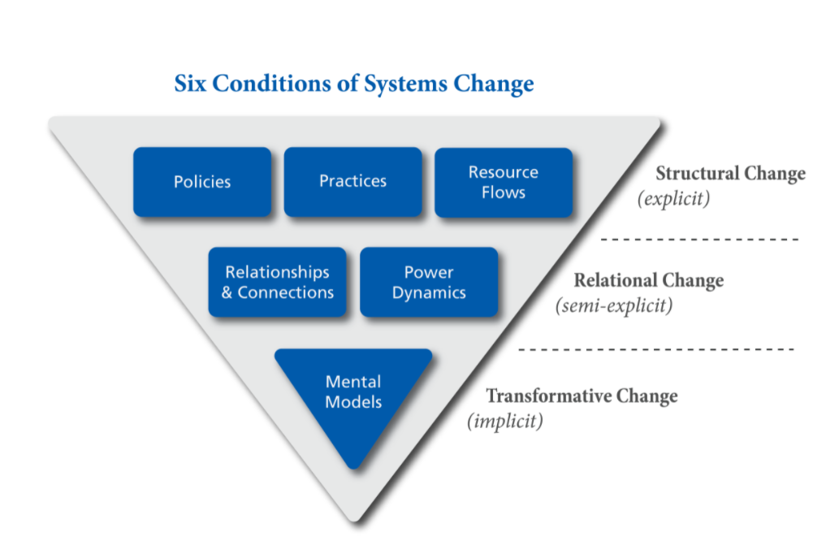
Hui participants were split into virtual break out rooms to discuss the systemic and structural barriers causing inequities, guided by the six conditions of systems change: Policies, Practices, Resource Flows, Relationships and Connections, Power Dynamics and Mental Models. Participants examined the existing conditions that reinforce the problem and barriers hindering our progress. Participants were also asked to re-imagine a future reality. In the breakout rooms participants brainstormed some potential strategies that could advance change within the system and discuss the emerging opportunities for transforming the system. The hui wrapped up through discussion of future steps as a collective, and ended with a whakawātea to reflect on the hui and clear the pathway.
Figure 1. Six conditions of systems change ^{[13]}

Online Survey Results

Close ended-questions – Demographics

Demographic | n=
Number of respondents | 84
Female | 70 (85%)
Male | 12 (15%)
Ethnicity
European New Zealander/Pākehā | 67
Māori | 9
Pacific | 5
Asian | 3
Other | 6

A total of 84 respondents took part in the online survey. Respondents were based across most regions in NZ (Figure 2) with most respondents being based in Wellington, Auckland, Canterbury and Northland.

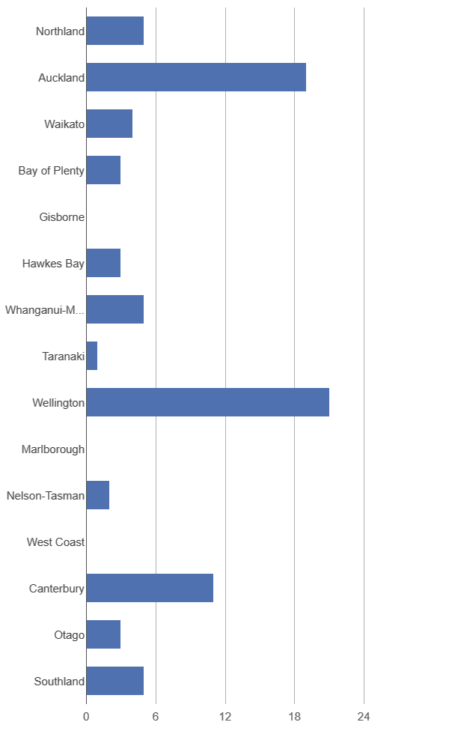
The majority of the respondents were clinicians who work in ear and hearing care or educators who work with whānau/families who have tamariki with hearing loss. (Figure 3)
Figure 2. Region’s respondents are resident
Other respondents included: manager of the NZ Deafness Notification Database, Advisor on deaf children [AoDC] (n=18), clinical managers, vision hearing technician, Senior advisor health and education, executive director, general manager, ORL nurse practitioner, specialist service lead deaf and hard of hearing, Kaitakawaenga Māori consultant and advisor, Regional Assistive Technology Coordinator, Vision and Hearing Technician Team Leader, Senior Advisor for a team in the Ministry of Education, Resource Teacher of the Deaf.
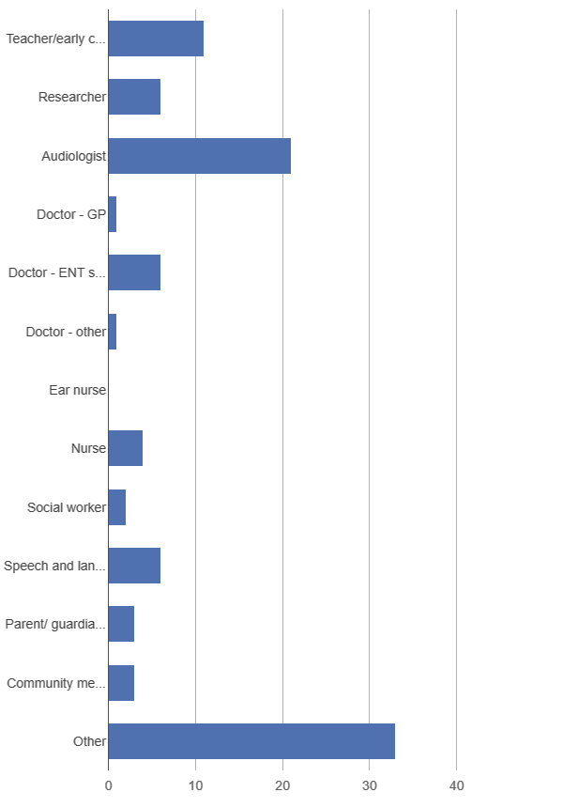
Figure 3. Title/Role of Respondents

Close-ended questions
- If you work in the area of ear and hearing health, what is the main age group which you work with?
Approximately half of the respondents (50.7%, n=36) worked with people of all ages, with 40.8% (n=29) working with 0–4-year-olds, 5.6% (n=4) working with 5-10 year olds, and 2.8% (n=2) only working with adults. (Figure 4).
Figure 4. Age groups worked with
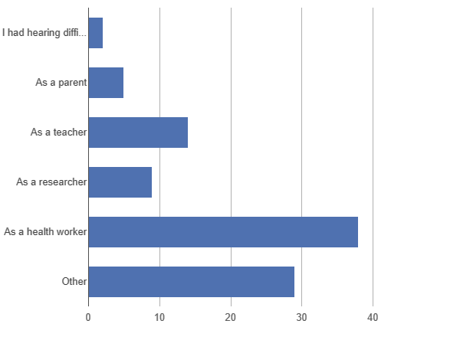
- How are you in contact with tamariki with hearing difficulties and/or ear disease?
Figure 5 Association with children with hearing difficulties and/or ear disease
Other: Involved community members, creating resources for DHH, as an AoDC, tamariki in the care of Oranga Tamariki, AoDC, relative of someone with a hearing loss, Regional Coordinator for Ko Taku Reo Deaf Education NZ.

- In general, how well do you think the needs of Māori and Pacific tamariki with hearing and/or ear conditions are met?
Figure 6. How well the needs of Māori and Pacific tamariki are met
Eighty-five percent of respondents agreed that needs were met “some of the time” (n=70). Of other participants, 13.4% (n=11) agreed “most of the time” and 1.2% (n=1) “none of the time”. (Figure 6).

Open-ended questions
Three broad themes were identified from thematic analysis of open-ended question data including: Tamariki missing out on EHHC and childhood development, barriers to support and health services, and facilitators and possible solutions for equitable EHHC provision. Refer to Appendix 1 for greater detail on the themes and sub-themes. A summary of the themes are presented below.

Theme One: Tamariki missing out on EHHC and childhood development
In the first theme, online survey participants identified that tamariki are missing out on EHHC and childhood development. Māori and Pacific tamariki were reported to have high incidence of Otitis Media with Effusion (OME) and have poor access to initial and follow-up ear and hearing health care (EHHC). Some respondents reported tamariki having late access to hearing technology, and in other cases, whānau have been unable to access the EHHC system so instead have learned NZ sign language (NZSL) to assist their tamariki with communication. Tamariki as well as their whānau members are missing out on EHHC and as respondents said are resultingly more likely to have ongoing difficulties with hearing and listening, and difficulties with childhood development.

Theme Two: Barriers to support and EHHC services
The second theme identified was the barriers to getting hearing support and EHHC services due to a very complex, inefficient and ineffective system. Barriers identified by respondents are mentioned below:
- Cultural barriers (examples of cultural barriers)
- Deficit framing of Māori and Pacific peoples
- Barriers to accessing EHHC support and health services
- Complex family situations
- Shortcomings in the healthcare workforce
- Lack of access to information and education for providers and community
- Lack of support for families
- Socioeconomic and Geographic barriers.

Theme Three: Facilitators and possible solutions for equitable EHHC
The third theme encompassed several suggestions and possible solutions identified by the respondents in providing equitable EHHC. These included:
- Improved education and awareness of hearing loss
- Need for more research in this area
- Improved service models (that are by Māori, for Māori; or by Pacific peoples, for Pacific peoples) and improved funding systems
- Need for community support services and resources
- Improvements in the workforce including the need for cultural safety training and whakawhanaungatanga.

Hui results

Participants
A total of 60 participants took part in the 3 virtual hui that were held in August and October. Participants were based in regions across New Zealand (Figure 7), but the majority of participants were from Wellington, Auckland and Canterbury.

Figure 7. Regions that the hui participants are resident.

The majority of the respondents were clinicians who work in ear and hearing care or educators/advisors who work with whānau/families who have tamariki with hearing loss. (Figure 8)
Participants also included: Researchers (n = 9, including academics and postgraduate students) and senior managers, including manager of the NZ Deafness Notification Database, Senior advisor health and education, executive director, operations manager, CEO and Chief Allied Health Professions Officer. We did not have profession data for 2 participants.
Figure 8. Title/Role of Hui Participants

Systems thinking: What’s holding the issues in place?
Systems thinking discussions in the virtual hui around the systemic and structural barriers creating inequities were structured around the six conditions of systems change including: policies, practices, resource flows, relationships and connections, power dynamics, and mental models. Through thematic analysis and several discussions with the project team, five key themes were identified from the virtual hui: EHHC and institutional racism, policies maintaining status quo, practitioner-patient power dynamics, workforce issues, perspectives of hearing loss. Detailed responses of participants for each theme are provided in Appendix 2.

Theme One: EHHC and Institutional Racism
The first key finding from the virtual hui discussion is that NZ has an institutionally racist EHHC system. The EHHC system is inaccessible for Māori and Pacific families with various delays to getting tamariki ears treated and fitted with hearing aid/s and thus delayed development and learning progression; thus widening the gap. One hui participant stated, the “trajectory for these (Māori and Pacific) kids is not good”.
Based on the discussions within the hui, several of barriers to accessing EHHC include but are not limited to: the current use of a one-size fits all biomedical EHHC model of care; the system being complex, inflexible, lacking innovation; the system not being set up to facilitate access with difficulties in obtaining transport, inflexible appointments, geographic isolation; as well as poor access to community clinics and health services in informal settings, difficulties in navigating the system when switching DHB services, poor access to funding, information and resources. One participant claimed that the “system is complex and is set up for people who can understand and navigate the system”.
As a Western EHHC system, these contributing factors to widening the gap in ear and hearing health for Māori and Pacific tamariki, could be deemed as institutional racism. A level of racism that is defined as “differential access to goods, services, and opportunities of society by race…. [and] often evident as inaction in the face of need” (pg. 1212, Jones, 2000) ^{[14]}. System racism operates independent of interventions and actions of individuals so that even if individual racism is not present, inequities for racial groups exist because of systems and programmes across society. This is also identified from other examples in the virtual hui discussions, where participants discussed that intergenerational health, wellbeing and whakapapa are disregarded in EHHC, wider family networks are not catered for, and multiple struggles are rarely considered, which consequently impacts whānau ability to access and engage with health services. This has been further acknowledged by some participants that have mentioned the limited voice, governance, and access to power that Māori and Pacific stakeholders, families and peoples working with whānau have in EHHC. To address this, there is a need for greater partnership and involvement of Māori and Pacific communities in not only EHHC but also the wider system.
Participants often expressed feeling under resources and ill-equipped to navigate these systems on behalf of and with whanau, frequently resorting to “work arounds”, achieving outcomes only with considerable amounts of additional effort.

Theme Two: Policies maintaining status quo
Another issue in place is that policies are maintaining the status quo. Participants stated that current policies are creating inequities in ear and hearing health among Māori and Pacific tamariki and whānau. A participant summarised this well and stated that with the present policies in place the EHHC system has “status quo solutions and put a plaster on it approaches.”
Many participants claimed the did not attend (DNA) policy is outdated, and in some cases several services have changed the DNA term to other names, for example, DNA was changed to was not brought (WNB) in one DHB, or “system failed to engage” in another. Several participants also claimed that the B4 School hearing screen at 4 years old is too late to screen tamariki for ear and hearing health if it supposed to be identifying and rectifying issues before the tamariki goes to school. The evaluation of services and particular clinical outcomes need to be considered such as interaction variables, whānau satisfaction of services, successes in connecting with whānau etc. Upon further discussions, participants state that these need to be rectified.
Furthermore, using a population health lens, many participants stated that wider public health policies need to be emphasised. New policies or current policies such as the ‘Healthy Homes Policy’ should be looked into to assist in closing the gap. Addressing inequalities and inequities in the social determinants of health will assist in preventing ear and hearing issues.

Theme Three: Power dynamics in EHHC
Another major theme that was picked up from the virtual hui discussions was practitioner-patient power dynamics in EHHC. The power imbalances in EHHC encounters between Māori and Pacific families, and EHHC practitioners whom a majority are non-Māori and non-Pacific, have rarely been examined. Participants however suggested that practitioner-patient power dynamics are present within EHHC and can affect communication and continuity of care. This could result in families having poorly built connections and relations with healthcare practitioners, mistrust with health care practitioners, and could lead to disengagement with the EHHC system.
Many participants discussed the mistrust and discomfort that Māori and Pacific peoples may have with the health system, with some having the fear that their tamariki could be taken away from them, which could be driven from historical factors, and experiences of racism and discrimination in health settings. Looking further into power dynamics, “there is an inherent gap between ‘clinical professionals’ and ‘patients’ that is, in part, due to the labels we give people and this is perpetuated by the current system, where the professionals need to operate from their ‘headquarters’ like the hospital, and everyone should make themselves available to the professionals if they need help”. This suggests that the current system fits ‘professional-centred care’ as opposed to ‘patient-centred’ or ‘whānau-centred’ care.
Within the discussions there were several examples of deficit assumptions, and deficit-framing of Māori and Pacific families. Some examples include: Māori and Pacific whānau and communities had poor health literacy, had a “lack of awareness”, were complacent or accepted low-level language skills of tamariki, and assumptions that “OME is expected from that community and thus an expected condition in these children is expected to be normalised”. Another participant stated that Māori and Pacific families
“Don’t understand the need to keep going to the hospital for monitoring. Don’t understand the point of returning to the clinic and having to go through all the access-related barriers every single time.” Rather than having a full understanding that these are systemic problems, the families have been deemed as the primary problem. This could signify that interpersonal racism or personally-mediated racism, discrimination and victim-blaming both conscious and unconscious, intentional and unintentional is present within the workforce.
In justification of this, some participants claimed that connections were sometimes difficult to develop due to lack of time or opportunities to discuss, lack of culturally appropriate services and training, loss of contact, constant rescheduling of appointments. Consequently, as one participant stated, “both sides lose faith in each other because of these inconsistencies and unreliability”.

Theme four: Workforce issues
The fourth theme takes a further look into discussions around workforce issues. At present, there are “not enough staff, too many children”. This suggests the importance of preventing ear and hearing issues as well as the need to look further into restricting our EHHC system as well as increasing EHHC workforce.
Within this, focus and priority needs to be put on increasing Māori and Pacific workforce. Several participants stated this is imperative because representation of workforce impacts whānau decision to attend or re-engage in appointments. Currently, participants stated that there are “no Māori in the room” or are “not visible”, and that we need a workforce that is representative of the population and population need.
For current and upcoming workforce, Māori and Pacific health training and professional development is required. This was noted as not only a need for professionals but a want by professionals, where several participants questioned the lack of training and awareness they have of the realities that whānau face, as well as the strength and resilience factors that are present in these families. What this training should entail has not been further elaborated upon in these early discussions.

Theme five: Perspectives of hearing loss
The fifth theme pertains to the mentality that underpins societal assumptions and attitudes about hearing loss. Several discussions stemmed around the view that hearing loss is stigmatised within society and “when something is invisible it is not given a priority”. This creates challenges in accepting hearing loss, hearing technology and accessing EHHC. For example, hui participants noted that some Māori and Pacific families are whakamā about using hearing aids. Supporting grief and loss responses can be challenging across cultural differences and may need more culturally safe design to support families.
Within discussions there were also notions that often hard-of-hearing and Deaf peoples are often lumped together. The way we frame hearing loss impacts on how hearing services are approached, and as a result may exclude certain community groups for example Deaf Māori and Pacific peoples from EHHC services. Therefore, there is a need to look further into the spectrum of views of hearing loss, and in the thought processes about inclusivity, to understand how inclusivity is being defined and by whom, as well as who is involved in the framing and awareness of definitions of hearing loss and people with hearing loss.

Re-imagining a Future Reality
Participants brainstormed potential strategies that could advance change in EHHC and discussed several emerging opportunities for transforming the system. An example of one group’s mind-mapped future reality of EHHC is seen in figure 7 below.
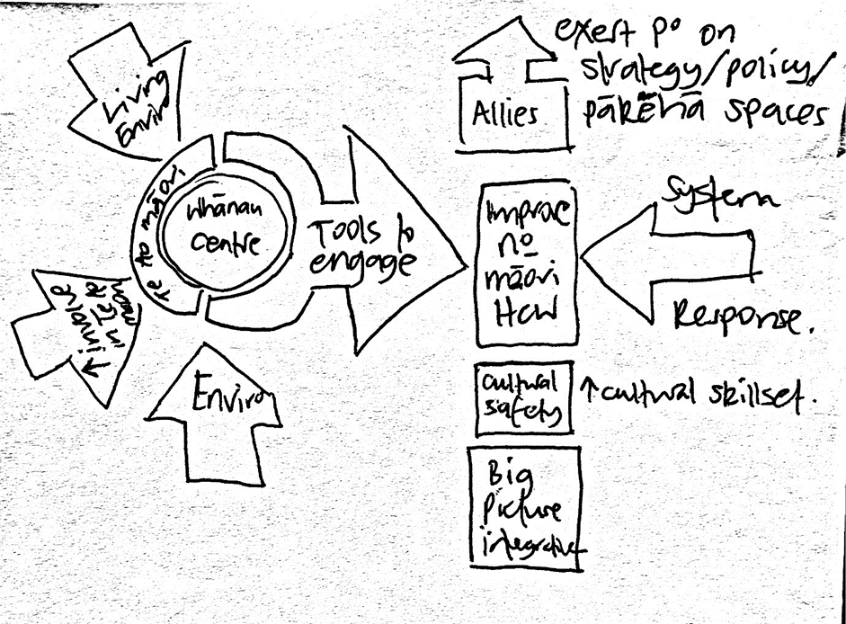
Figure 7 Framework for change
Key themes identified from group kōrero of re-imagining a future reality include:
- Systemic and structural changes and improvements
- Policy and funding of services
- Improving communication and resources
- Education and awareness
- Addressing power dynamics.
Further detail of each of these themes are summarised in a table in Appendix 3.

Future Research Directions
Research directions from hui participants included the following suggestions:
- Understand what consumers want? Develop solutions in partnership with whānau. Move away from biomedical model of health to a holistic approach with whānau, wrap around services
- Improve data collection and collation - join up data collection for the life of a child, eg UNHSEIP + B4 school check
- Understand lived experiences of Māori and Pacific tamariki and whānau on hearing loss, hearing technology, middle ear issues, and EHHC.

Collective Action Building

E hara taku toa i te toa takatahi, he toa takitini
My strength is not as an individual, but as a collective

Collective Action Building is a movement that requires different parts of the ecosystem to move in the same direction, sharing the same vision and measures of success, spotting the actions that will generate momentum. Everyone has a role to play in creating the conditions for systems change. It involves activating your sphere of influence – no matter how small.
Several collective action points were determined at the last virtual hui and in reference back to the online survey results. Within the last virtual hui, as participants re-imagined a future reality of EHHC for Māori and Pacific families, they brainstormed within breakout rooms and considered and shared their sphere of influence, personal advantage and what influence they could have if they joined with someone else or with others in their sphere of influence.
Many participant groups in the virtual hui maintained that tamariki and whānau-centred care should remain at the heart of the collective action building movement. Further to this, as we work towards reducing and eliminating the issues and a re-imagined future reality it is important that we instil the articles, principles, and values of Te Tiriti o Waitangi, take a rights-based approach to EHHC and ensure that Māori and Pacific peoples have governance over the processes within the collective action building movement for EHHC.
For example, as we consider the action points below, there will be partnership and participation with whānau and communities woven through these workstreams. This could be considered like a mat which the foundation of communication sits upon, with the strands of the action points and participants communities and professionals woven together to provide a strong and durable platform.

The collective action points discussed are highlighted within the following six points:
- Collaboration and partnerships: working together with various networks (professionals, community leaders and communities) and softening boundaries between the different disciplines to create, build, and maintain equitable EHHC
- Being in the community: Creating and providing ear and hearing care services in the community with the community
- Communications, marketing and engagement: Developing messaging around hearing and hearing loss for communities, educators, primary health
- Research and knowledge sharing: working with communities to create research that will be part of creating equitable transformative EHHC
- Government relations and advocacy through political movements
- Building and growing a culturally safe workforce
Achieving these action points together will require time, flexibility and critical self-reflection for each and everyone involved in the creation of equitable EHHC. Future directions for the collective action building movement will involve connection and working with key community groups informing the framework of such actions.

Conclusions: Ngā kōrero whakamutunga
Our initial steps of this project aimed to construct a multi-organisation plan to promote further research and community projects and to inform problem-solving. These preliminary project findings highlight the collective desire of health and educational professionals to address inequitable outcomes in ear and hearing health for Māori and Pacific tamariki in NZ. The project has proven a strong desire to change the status quo; with discussions around policies, practices, resource flows, relationships and connections, power dynamics and mental modes, key themes have been identified by hui participants to understand what is holding this problem in place. In-depth discussions around the systemic issues have resulted in discussions of many innovative solutions. Next steps and collective action points - collaboration and partnership, being in the community, communications, research and knowledge sharing, government relations and advocacy, and building cultural capability, will form the basis for working groups to advance this work further and maintain the momentum for change. Keeping momentum, the work will now be extended to meeting and connecting with Māori and Pacific community-based groups and whānau to hear their voices and experiences to improve equitable hearing health outcomes for Māori and Pacific tamariki in NZ.

He pakaru a waka e taea te raupine mai
A damaged vehicle can be repaired

References
[1] World Health Organization. Childhood Hearing Loss.; 2016. http://www.who.int/mediacentre/factsheets/fs300/en/.
[2] Review Team to Consider Hearing Impairment Among Māori People. Whakarongo Mai Māori Hearing Impairment. Wellington; 1989.
[3] Kuh D, Yoav B-S, eds. A Life-Course Approach to Chronic Disease Epidemiology. Oxford: Oxford University Press; 1997.
[4] Paterson JE, Carter S, Wallace J, Ahmad Z, Garrett N, Silva PA. Pacific Islands families study: The prevalence of chronic middle ear disease in 2-year-old Pacific children living in New Zealand. Int J Pediatr Otorhinolaryngol. 2006;70(10):1771-1778. doi:10.1016/j.ijporl.2006.06.001
[5] Purdy SC, Taylor S, Schluter PJ, et al. Hearing and ear status of Pacific children aged 11 years living in New Zealand: the Pacific Islands families hearing study. Int J Audiol. 2018;58(2):77-86. doi:10.1080/14992027.2018.1506170
[6] Digby JE, Purdy SC, Kelly AS. Deafness Notification Report (2017) Hearing Loss (Not Remediable by Grommets) in New Zealanders under the Age of 19. Auckland, New Zealand; 2017.
[7] Johnston J, Mclaren H, Mahadevan M, Douglas RG. Surgical treatment of otitis media with effusion in Māori children. 2018;88:1141-1144. doi:10.1111/ans.14788
[8] Simmonds S, Carter M, Preval N, Wilson R. Baseline Data Capture: Cultural Safety, Partnership and Health Equity Initiatives: Final Report. Wellington; 2020.
[9] Health Quality and Safety Commission. Window on the Quality of Aotearoa New Zealand’s Health Care: A View on Māori Health Equity. Wellington; 2019. doi:78-0-908345-94-6
[10] Health Quality & Safety Commission. Bula Sautu: A window on quality 2021: Pacific health in the year of COVID-19. 2021.
[11] Tuhiwai Smith L. Decolonising Methodologies: Research and Indigenous Peoples. London: Zed Books; 1999.
[12] Braun V, Clarke V, Terry G. Thematic Analysis. In: Rohleder P, Lyons AC, eds. Qualitative Research in Clinical and Health Psychology. First edit. Hampshire: Palgrave Macmillan; 2015:95-113.
[13] FSG. Six conditions of systems change. https://www.fsg.org/publications/water_of_systems_change#:~:text=The Water of Systems Change aims to clarify,particularly those who are working to advance equity. Accessed December 13, 2021.
[14] Jones, CP. Levels of racism: a theoretic framework and a gardener's tale. American journal of public health. 2000; 90(8):1212-1215. doi:10.2105/ajph.90.8.1212

Appendices

Appendix 1: Table - Themes from online survey
THEMES/SUBTHEMES | DESCRIPTION
Theme One: Tamariki missing out on EHHC and childhood development
Evidence and observed reports of inequities | Some are saying there is actually good evidence showing that inequity exists for Māori and Pacific children. The extent of inequalities is great and has large implications. Observed high incidence of OME among Māori and Pacific children
Late access to HAs | Children are getting late access to hearing technology
Learn sign language, as can’t access EHHC system | Whānau can’t access EHHC system so instead learn NZSL in the meantime.
Loss of children with high frequency hearing loss | Lose children with high frequency hearing loss in the system
Missing out on key learning milestones | Children missing out on developmental learning milestones
Theme Two: Barriers to support and EHHC services
Complex system - Ineffective and inefficient processes within the public health sector | Complex system and poor coordination between services. Poor confidence in navigating health system.
Constrained services with inadequate resourcing | Workforce is overworked, overloaded, and under resourced
Difficulties engaging with services and follow up | Lower level of follow up for Māori and Pacific of those referred from B4SC hearing screening
Long wait lists to see ENT and audiology | Lengthy wait times.
Poor access to APD assessments and support | Difficulties with accessing APD assessments and help
Screening barriers | Various hearing screening barriers including children getting screened too late. B4 school screening is too late to prevent language related learning delay at time of school entry
System is Eurocentric | Western Eurocentric health care system creating barriers for Māori and Pacific
Cultural barriers | Hearing loss and identity. Hearing loss reported to not be accepted in some cultures.
Families issue - deficit focused | Providers victim blaming families for various reasons
Families lack of engagement with services | This also includes referrals not being actioned by parents
Lack of support and commitment from whānau | Providers reported lack of support and commitment from whānau to wear HAs, to attend appointments, to manage conditions
Low concern of slow speech acquisition | --
Missed appointments and the DNA burden | Various people reported missed appointments were due to the family. DNA burden and loss of follow up
Poor health literacy and misunderstanding of information | View of workforce families have difficulties with understanding information
Stigma - Poor acceptance of hearing loss and hearing aids | Blaming families and their beliefs for not accepting hearing loss and hearing aids
Family situations | Various reasons for not being able to make appointments
Transiency | Children in state care and those moving from one area to another drop out of the system
Children in whānau with complex social needs | --
Difficulties using hearing aids while children are unwell | --
Time, availability, and inflexibility of appointments for whānau | Whānau have to take leave to get son/daughter to appointment, can’t take time off work, childcare issues.
Healthcare workforce | Barriers to do with healthcare workforce
Bad experiences with HC workers | Various poor experiences with HC workforce. Poor relationships with whānau. Families feeling uncomfortable, unwelcome, or distrust with health system. Not feeling comfortable with visiting doctors
Poor leadership on hearing loss by professional groups | Professional groups not advocating and pushing this agenda forward
Shortage of key providers & workforce | --
Lack of access to information and education for providers and community | Access to information about services, hearing loss, ear health, hearing technology, APD, and support. Low awareness of services. As well as awareness of the wider community where Deaf and Hard of Hearing ākonga and whānau live. Lack of simple information.
Bad experiences with HAs | Difficulties managing HAs
Lack of data and poor awareness of the incidence of hearing loss | This could pertain to the lack of data, which makes it difficult to measure and quantify the need (in respect to numbers). Lack of clarity on the problem
Language barriers | --
Miscommunication or misinformed | Misinformed at UNBHS
Poor awareness of the implications of hearing loss and ear conditions | Poor awareness of condition and need for education of condition
Prioritisation - Hearing loss at the bottom of list of health issues in health sector | --
Lack of support for families | Lack of current support and need for more support for families to attend appointments and follow up. Whether it be physical support/funding support/support to get to appointments and navigate the system etc. Reports that whānau are unaware of support services available and how to access those. Thus need to support EHHC workforce and whānau.
Socioeconomic & Geographic Barriers | Various socioeconomic and geographic barriers
Affordability | Even when services were free, accessibility issues still exist
- Complex funding system for HAs | System is difficult to understand e.g. difficulties meeting funding criteria for hearing technology.
- Expensive medication for ear infections | E.g. Ciproxin.
- Limited access to internet and phone | This may pose difficulties with getting in contact with each other.
- Transport and parking difficulties | Difficulties getting access to vehicle, petrol, license. Various parking difficulties.
Location of services | --
- Poor access to community and mobile clinics | Difficulties accessing community clinics in familiar spaces, especially those living in a rural area. E.g. earvans marae church
- Tamariki in transient homes and loss of contact | Frequent changes in addresses, loss of contact
Theme Three: Facilitators and possible solutions for equitable ear and EHHC provision
Education and awareness of HL | --
Advocates in community for hearing loss (champions) | --
Hold government and health care system accountable for inequities | --
Increased education of hearing and ear care, other means of communication and development | --
Need for more research in this area | --
Services | --
Better access to community, mobile, school clinics | E.g. libraries, day-cares, public health areas. Multidisciplinary focused clinics within outpatient environments, and/or within the community setting. Wax clinics. Better location of clinics, particularly rurally whom are missing out
Better communication and coordination of services | Consistent resourcing across regions
Change service delivery model | Tamariki are well-looked after in Māori-led services. One stop shop ear and hearing health service.
Earlier and continued screening | Earlier than b4 school check. NBHS helps with identification.
Improved timely action | --
- Flexibility of appointments | Look further into flexibility of appointments
- Red flag alert system | Alert system for services, so we don’t lose children to follow up.
- Reduce wait times | Examples of how we may be able to reduce wait times.
- Streamlined referral systems | --
More affordable services | --
- Greater funding support | Funding support for private audiology services to increase accessibility
- Subsidised delivery of services | Subsidised delivery by Pacific for Pacific
Tautoko - need for support | Need for support and resources
Community based support | Community and school based support
Need for proactive referrals for intervention | Proactively referring tamariki to necessary hearing / ear services
Need to support PHN, community support services | These services can assist with attending appointments
Opportunities to engage with providers, communities, and whānau | --
Resources | --
- Development of appropriate resources and Māori specific tools, and consistent resourcing across regions | E.g. te reo Māori assessments and resources
- Need for proactive referrals for intervention | Proactively referring tamariki to necessary hearing / ear services
Travel vouchers or services | --
Whānau are important - Need for family centred care | --
Workforce | Several improvements in workforce is needed
Increase workforce numbers | Increase number of AoDC, ear nurses, and audiologists in specific areas
Representative workforce | Increase Pacific and Māori workforce
The need to upskill our workforce | Need for cultural responsiveness, in education about hearing loss. Audiologists refer children directly onto grommet waitlist.
- Culturally appropriate, cultural safety education | --
- Whakawhanaungatanga, building relationships | --

Appendix 2: Table – Virtual Hui themes
Systems thinking: What is holding the issues in place?

Theme | Detail
EHHC and Institutional Racism | - System is complicated  - System is inflexible, rigid ideals, lacking innovation  - System is set up for people who can understand and navigate the system  - Trajectory for these kids (Māori and Pacific) not good  - System not set up for facilitate access – e.g – transport to appts, release from school etc  - Practices reactive, not proactive  - Co-existing problems  - Families have multiple struggles  - Geographic isolation  - Poor access to community clinics (e.g. church/marae services) or informal health service settings  - Difficulties navigating the system when switching DHB services  - Constant movement of whānau and loss of contact with whānau  - Regional variations not taken into consideration  - Transport to appointments  - Questions raised around who they ask for help to support patients with transportation  - Late fitting/ limited use makes the ability to close the gap harder  - SLT referrals are late, or nil input until getting to AoDC  - Mobile families, loss of connections, no other points of contact to keep track of the family  - Clinical outcomes need to consider the effectiveness of the clinical interaction (interaction variables such as attendance at appointments, family satisfaction with services, success with connecting with families etc.) rather than just numbers seen.  - Poor awareness/promotion of services - Don’t know what other services exist.  - Medical teams are gatekeepers to services (not sure what services these are) - GPs  - Technology not being utilised to it’s potential (far from)  - Explaining why so many patients comply and understanding the pathology or the treatment.  - Cost for devices + fitting services  - Access is limited and prioritise fitting people into clinics instead of allocating resources to go to the community.  - Wider family networks not catered for – parents or caregivers have to attend appts so they can give consent.  - Services don’t consider intergenerational health and whakapapa.  - Compounding nature of various issues that influence families’ ability to access and engage with health services.
Policies maintaining status quo | - Current government policies do not allow for whakawhanaungatanga, trust and relationship building, talking with people about personal information.  - Before school check is too late  - Healthy homes policy, Smokefree Aotearoa policies are important policies that could influence ear health outcomes  - DNA policy is outdated (AoDCs 3 Did not attend file is closed)  - Access to correct information – media, friends, health system and that people feel empowered to act on it.  - Status quo solutions and put a plaster on it approach  - Clinical outcomes need to consider the effectiveness of the clinical interaction (interaction variables such as attendance at appointments, family satisfaction with services, success with connecting with families etc.) rather than just numbers seen.
Power dynamics in EHHC | - There is an inherent gap between “clinical professionals” and “patients” that is, in part, due to the labels we give people (e.g. professional, instead of community representative). This is then perpetuated by the current system, where the professionals need to operate from their “headquarters” like the hospital, and everyone should make themselves available to the professionals if they need help.  - Mistrust with the system. Fear that children could be taken away from them. Historically driven.  - Mistrust happens between the people who go into family homes and the families.  - Appointments keep being rescheduled, and both sides lose faith in each other because of these inconsistencies, unreliability…etc.  - Anxiety providing communications and process  - People disengage from the system  - Discomfort in heath setting, experiences of racism, discrimination, and victim-blaming.  - Lack of education around ear and hearing health – e.g. in ECE’s and schools  - “Complacency” or “acceptance of low-level language skills” and poor speech  - Whānau and community “lack of awareness” as to the level of disability of hearing loss, understanding of long-term effects of hearing loss  - No time/consideration given to families time to come to terms with the loss of the child that is fully able.  - Lack of time, lack of opportunities for discussion, sometimes from a cultural perspective, and then the inequities just snowball because of the start of this cycle  - OME expected from that community, an expected condition in these children is normalised  - Don’t understand the need to keep going to the hospital for “monitoring”. Don’t understand the point of returning to the clinic and having to go through all the access-related barriers every single time.
Workforce issues | - No Māori in the room/not visible  - Workforce that is representative of the population and population need  - Not enough staff, too many children  - Lack of awareness of health care and educational workers regarding the realities of the lives of whānau as well as the strength/resilience factors that are present in these families.
Perspectives of hearing loss | - Lumping together  - Understanding the invisibility of disability  - Invisible disability and a hidden problem so can pass unnoticed  - When something is invisible it is not given a priority  - What do we want to achieve – what is the endpoint (?)  - Whakamā about using hearing aids  - Cultural issue for Samoan children in Church with Hearing aids  - Hearing is disability rather than health.

Appendix 3: Table – Re-imagining a Future Reality
Theme | Detail
Systemic and structural changes and improvements | - Addressing structural / institutional racism  - De-medicalising the medical system  - Child and whānau centred  - Addressing structural and institutional racism  - Free ear and hearing health services in the community - ear buses!  - Decolonise :)  - Ear nurse and community health regular services at Marae  - Ongoing review of the amplification is it fitting the purpose, school and preschool regular assessment of hearing health  - Better systems to enable whānau to access services without time frames etc  - Provision of community-based services (e.g. ear buses) - Access with surgical buses, Regular ear nurse and community health services at Marae, churches i.e. in places where communities feel more comfortable.  - Need single point of access – e.g. anyone can refer to central person that knows the whānau to bring together the appropriate multidisciplinary team. Stop families from having to retell their stories to each person on the team, and thus keep everyone on the team informed etc. Work together to streamline services for families.  - Softening the boundaries between disciplines  - Child and whānau centred care - Wrap around linked up services that look at the hauora of the whānau  - Parent partners model for SLT  - Wider whānau  - Support groups  - Provide services that are outside the typical 9-5pm  - Audiologists to move outside their sound booths
Policy and funding of services | - Collaboration between workers in ear and hearing health  - Fund DHB services for the proportion of community-based initiatives and how many repeat appointments for whānau  - MOH look at the structural and economic inequity of ignoring middle ear disease  - Require a different way of funding and measuring outcomes  - Free ear and hearing health services in the community - ear buses  - Fund DHB services for the proportion of community-based initiatives and how many repeat appointments for whānau as a positive that they keep coming  - Acknowledging Māori and Pacific rights to accessing equitable services  - Changing the way we address DNA: using wider community links to gather attendance, taking services to communities, how are GPs assessing and talking to patients regarding ear and hearing health.
Address Power Dynamics | - Understand that things are changing for families, one incident may lead to disengagement – have a range of contacts for people.  - Study of hearing health in Niue – good hearing health because communities are connected and services are not siloed  - Building trust in relationships helps to get better results  - Need to consider whakapapa and whānau navigators and how those navigators will be utilised within a rebuilt system.  - Patient stories “adults reflecting on their journey” parent who had a lifetime of unaided hearing loss and missed out  - Coping with shame of hearing loss (individual or whānau)  - connecting with the community of practice in challenging situations  - Engage whānau as a whole - grandparents are often deferred to  - better communication between all stakeholders  - Hold multidisciplinary team meetings to talk about each child that has three DNAs to see if there are challenges that other disciplines know about for that whānau  - Getting the right people in the room together  - Cultural security and engagement  - Culturally appropriate community support people  - More diverse workforce  - More representative workforce - more Māori audiologists!  - more representative workforce  - Encourage Māori community workers  - Workforce which better represents the population  - More ear nurses in the community  - More kaimahi across all services with te reo Māori and te reo sign  - Support people and mentors in the community for all vulnerable families or when it becomes evident a family to struggling to cope with the health system  - Having culturally appropriate community support people - Māori and Pacific Community Health could be the first point of contact.  - Mentorship tuakana/ teina; in person or distance  - Cultural safety training: how can we make our services more “fit for purpose”  - Medical models at Universities – need to broaden teaching into health equity and cultural safety.
Improve Communication and Resources | - Parking – pay or provide transport  - Cohesion between services – what are others doing, how can we help  - Website with information and resources: parent and whānau areas and clinical areas for COP to use/ discussion forums  - Resources dictated by the need for the child and whānau rather than resource allocation first  - At the first (or unable to attend) look to an opportunity for engagement: explore in your area resources....community workers, GP practices/ nurse, schools, social worker, Māori health support....try ringing again at different times of day...we have had much better results with this  - Better use of technology to test where people are most comfortable  - Centralised resources for clinicians  - Outreach clinics utilising technology, change beliefs you need bigger equipment.  - Collaboration between workers in ear and hearing health - Do ENT/ GP/ audiology do referral to SLT early enough esp in OME or other (non-SNHL)– what about using ‘little ears’ as a screening tool on receipt of referral, getting parental consent for referral then  - More accessible language used to describe professionals and clinics and in the letters that are sent to the parents.  - Opening pathways of referral (not sure to whom): more detail needed  - map of practitioners and contacts: who does what and where to refer  - Having online bookings  - Kaimahi in Hawke’s Bay helping with transport  - Education services overwhelmed with referrals for SLT; ? meet with them to discuss a triage  - Tech: Develop/ link to existing online tools for SLT, Social media options eg facebook pages, Instagram links, Phone app?? – like duolingo: today’s practice reminder to your phone, podcasts.
Education and awareness | - Educate in the community – e.g. events – we need to be the “face” for “ears”  - Educate via social media  - National set of resources that explains the conditions and treatments

Resources and Websites recommended in Virtual Hui
- Talking matters: https://www.talkingmatters.org.nz/
- Much more than words: https://seonline.tki.org.nz/Educator-tools/Much-More-than-Words
- Picking up the pace: https://www.educationcounts.govt.nz/publications/pasifika/4971
- The following might help the community of practice to think about linking in with other services to support whānau: https://developingchild.harvard.edu/resources/video-building-core-capabilities-life/
- Now I don’t know my ABC report: https://theeducationhub.org.nz/now-i-dont-know-my-abc/
- KUDUwave for full diagnostic audiology (bone + HF air + tymps) outside a booth/van/bus: https://emoyo.net/kuduwave/kuduwave-pro-2/

Eisdell Moore Centre for Hearing and Balance Research
Section of Audiology, The School of Population Health
Faculty of Medical and Health Sciences
Building 507- 28 Park Ave, Grafton, Auckland 1023
W auckland.ac.nz
The University of Auckland
Private Bag 92019, Auckland 1142
New Zealand

Māori respondents consisted of: 1x doctor, 1x vision hearing technician, 1x community health worker, 1x nurse and senior advisor, 1x social worker, 1x Kaitakawaenga, Māori consultant and advisor, 2x teacher/ECE educator, 1x parent/guardian of a child with hearing loss; Wellington based n=6, Southland-based n=3).
Pacific respondents consisted of: 1x Audiologist, 1x doctor (GP), 1x Social worker and parent/guardian of a child with hearing loss, 1x Community member& Executive Director, Community member, General Manager, 1x parent/guardian of a child with hearing loss; 1x Auckland, 2x Wellington, 1x Whanganui-Manawatu, 1x Hawkes Bay.

